## Login

1. 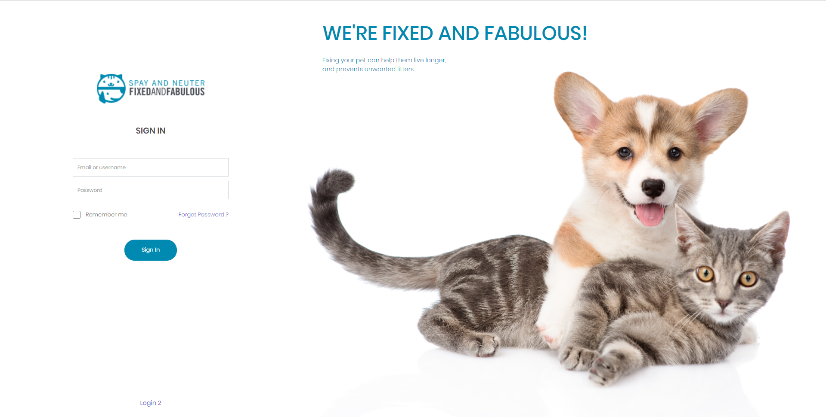Login to The system.
2. 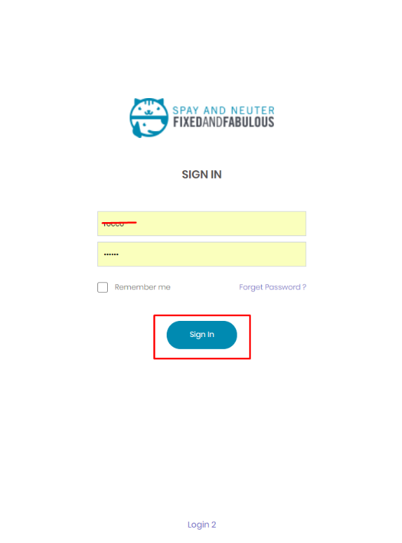Enter the Username and Password and click the Sign In button
3. 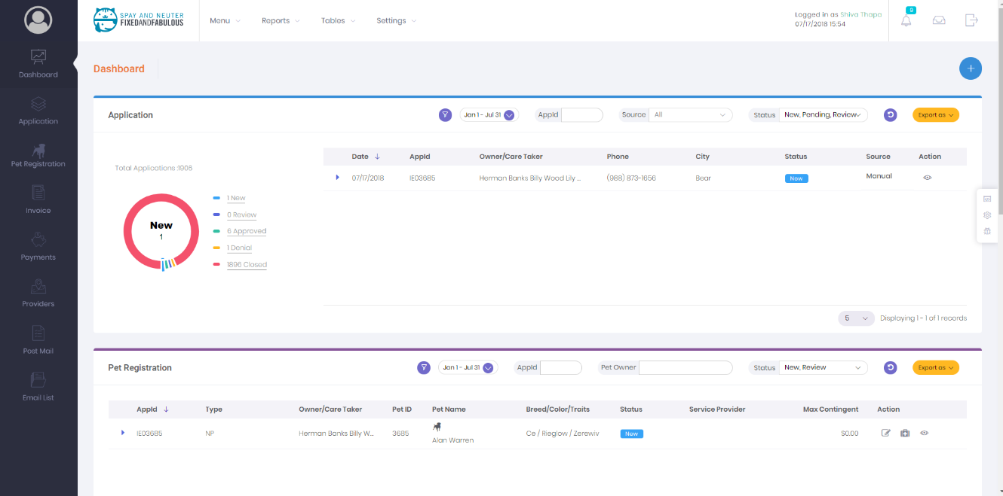You will be redirect to the dashboard

# User

## How to create a new User?

1. To create new user click on settings located at top menu
2. Click on the User Control under System Management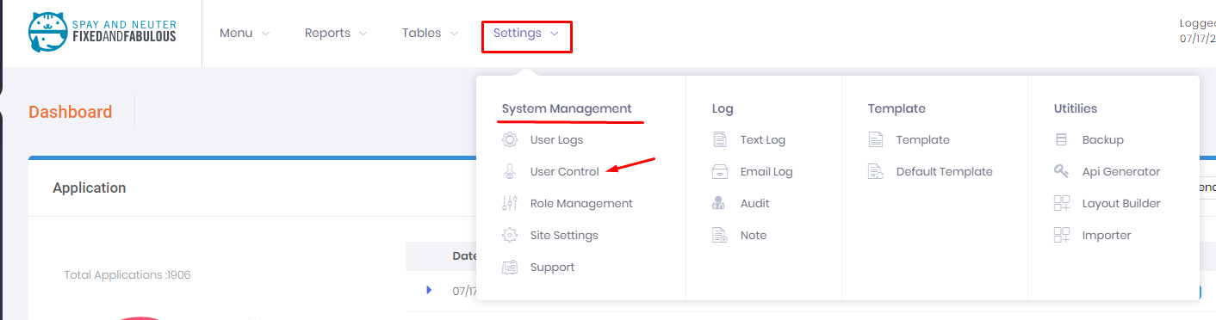
3. On the right hand side there is Add User Button click it.
4. A Popup form will show. 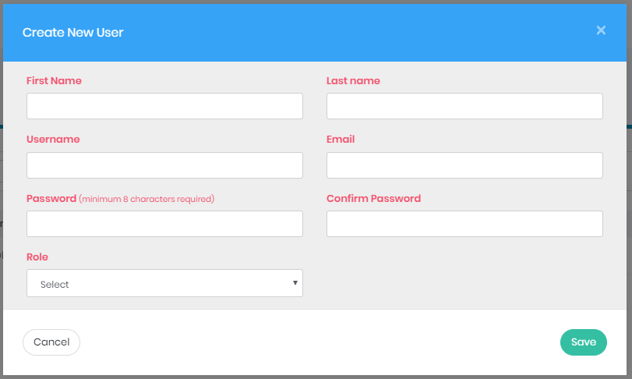
5. Fill The Form Correctly. The red label indicates that the field is mandatory
6. Choose the Proper Role For the User
7. Click the Save Button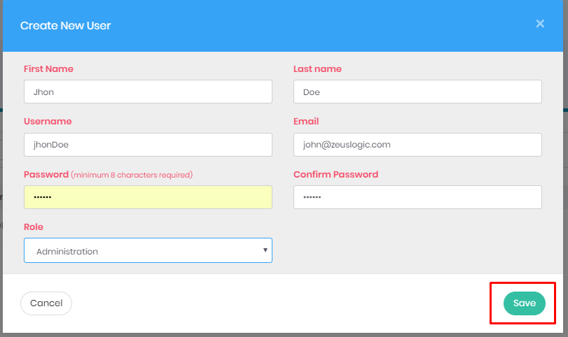
8. A success Message will be Display and 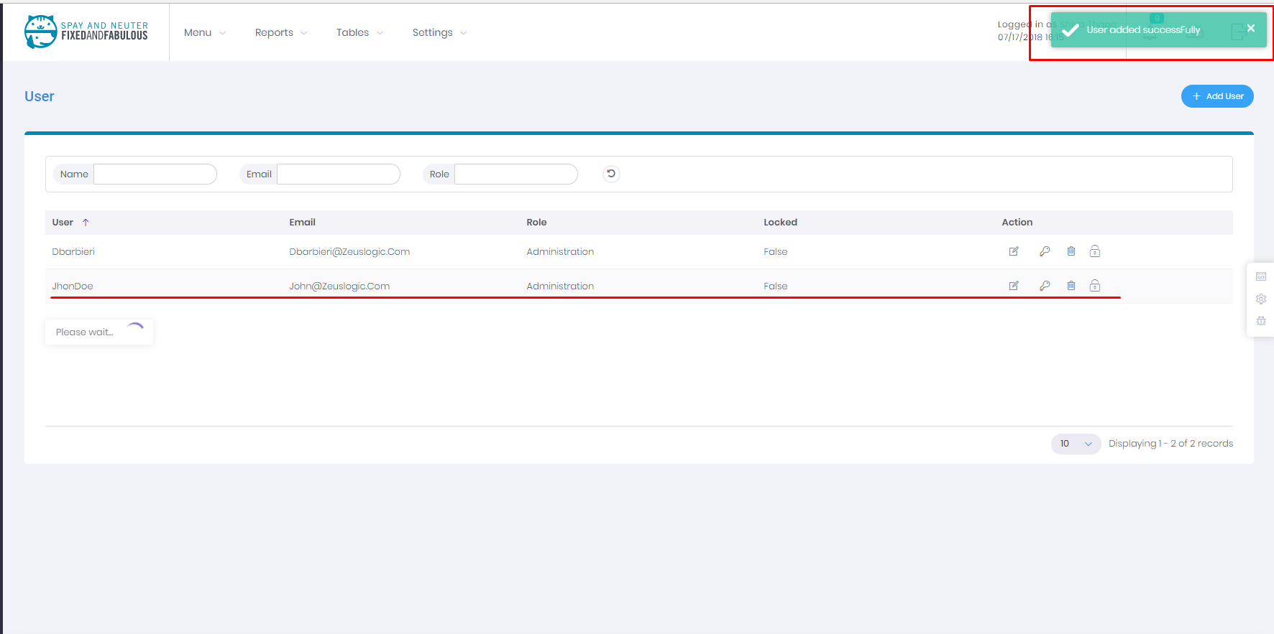

List of the Button and Their Work in User Page

|  |  |
| --- | --- |
|  | To edit the Existing User |
|  | To Change the Password of user |
|  | To delete the Existing User |
|  | To lock user until certain time |
|  | To Add a new User |

## How To edit user?

1. Click on the edit icon next to the user you want to edit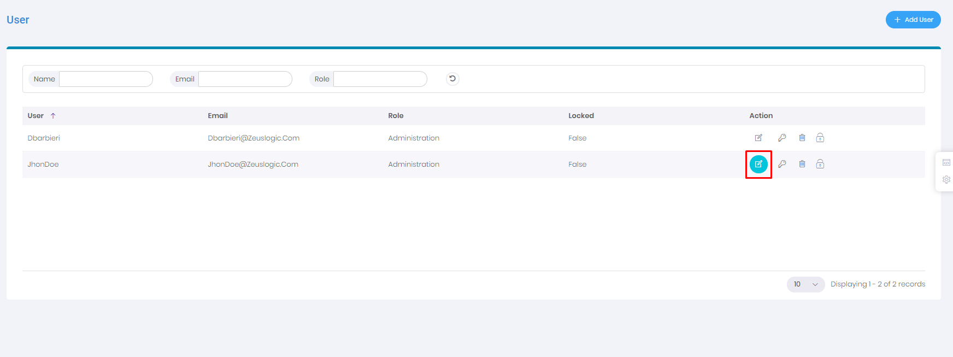
2. A popup form will show (note: to change password see How to change password) 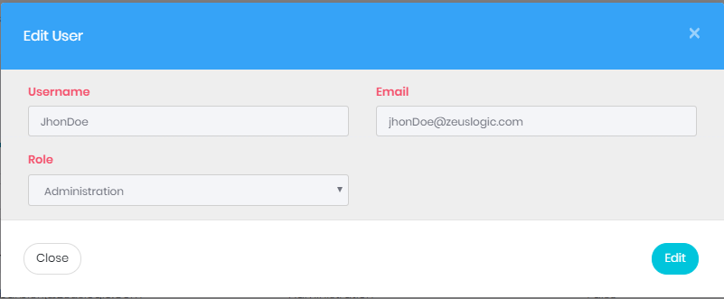
3. All field are disabled to enable click edit, all field will be enabled and save button will show
4. Click the save button located at right hand side a success message will show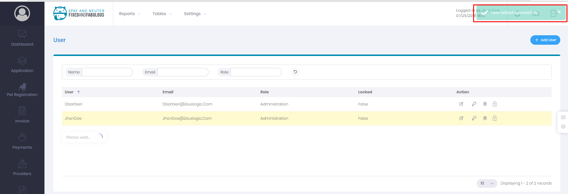

## How to Change Password?

To change password there are three options

1. Change password of own (For all user role)
2. Change password of another user (Administration)
3. Change password from the Login screen

### Change Password of own

1. Click on the user icon 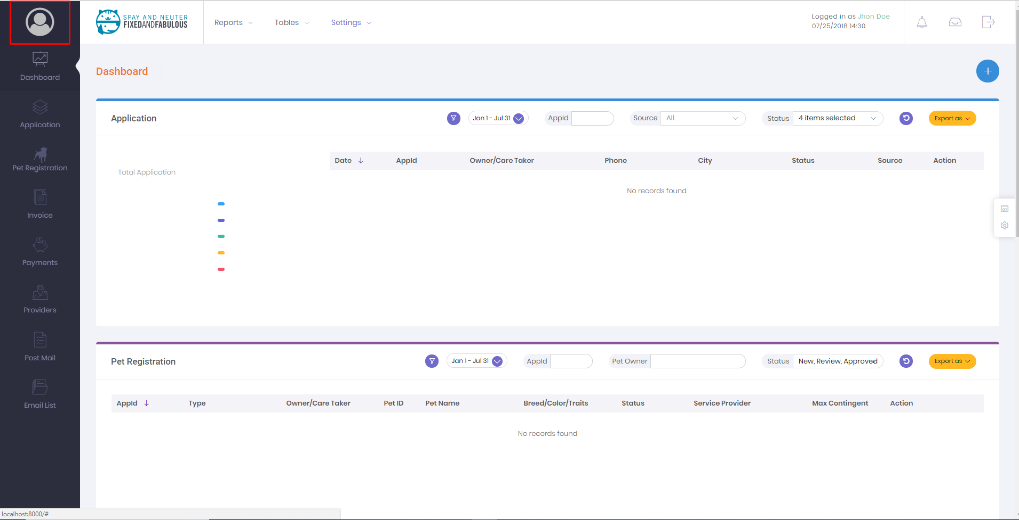
2. A Profile will open
3. Click on the change password tab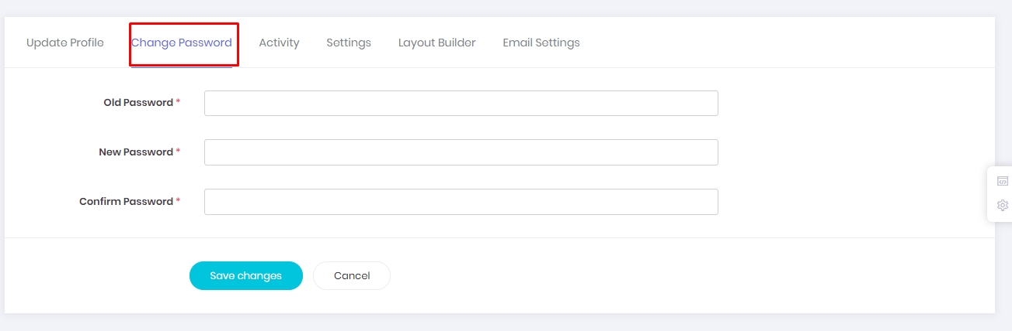
4. Insert Your old password and new password and click save Changes button. 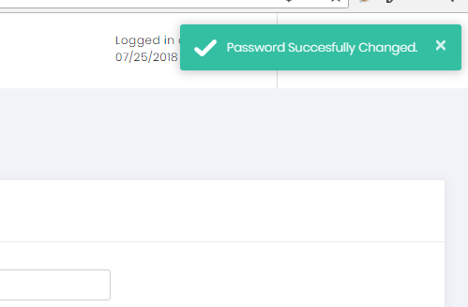

### Change password of another user

1. Go to settings > user control
2. Click on the change password(Key icon). 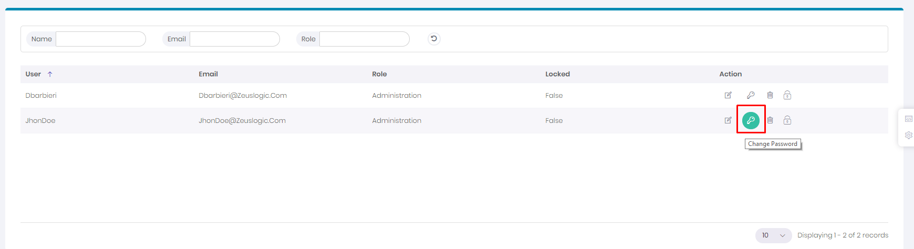
3. A popup will open 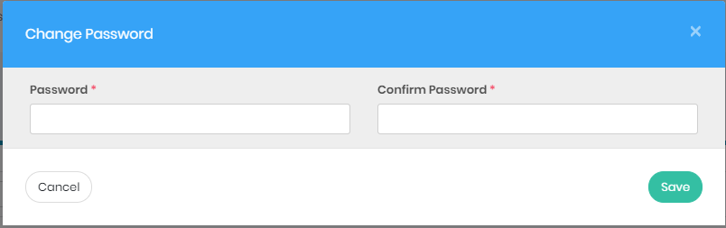
4. Enter the new password and save 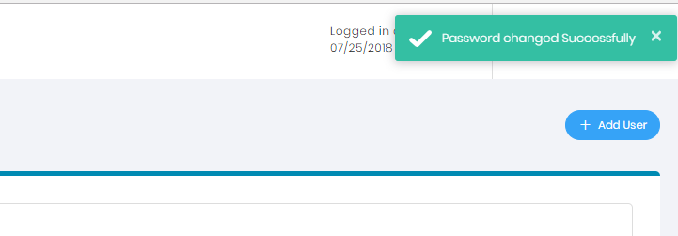

### Change password from login screen

1. On the login Screen click on forget password 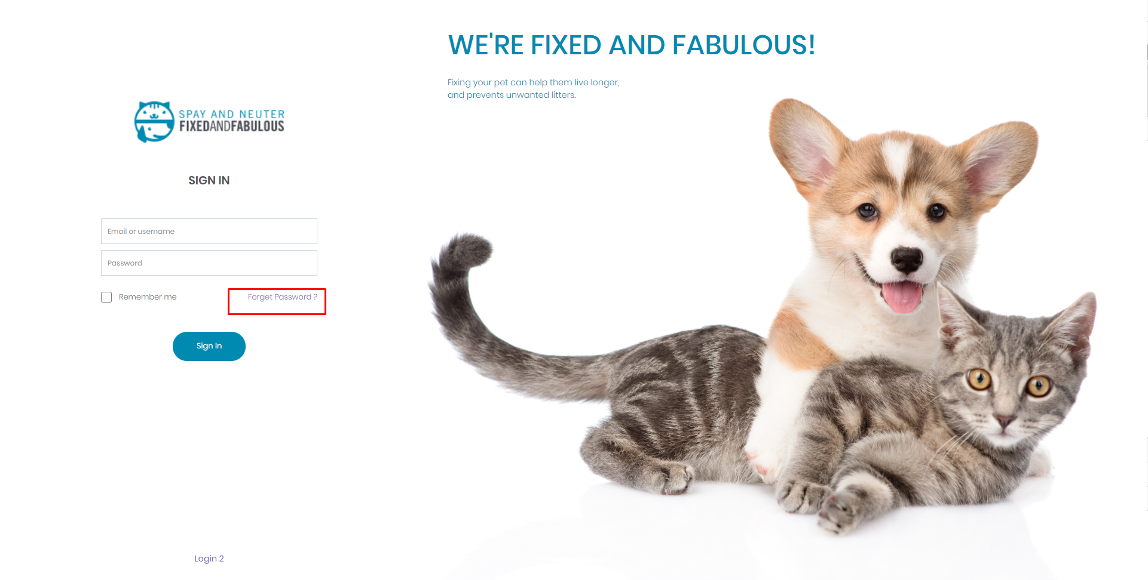
2. Insert Your Email address and click on request
3. A Reset link will be on your email addres

# Providers

## How to add new Provider?

1. Click on the provider in side menu 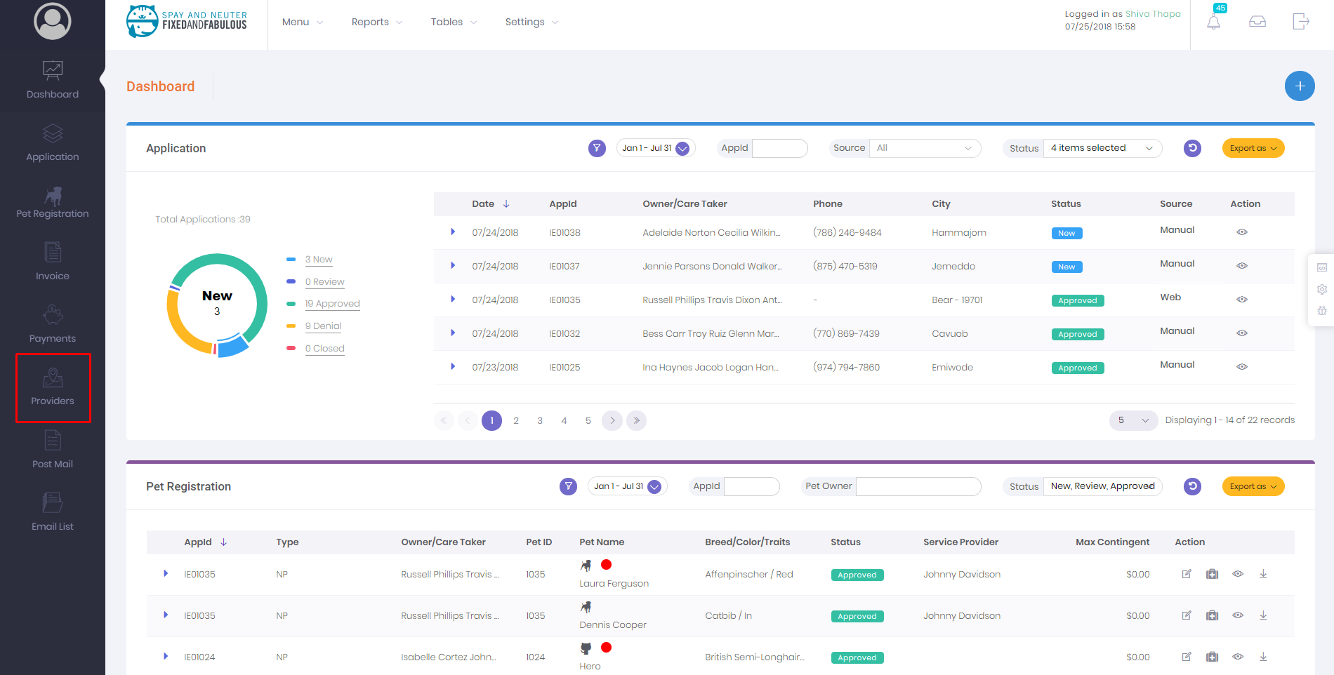
2. On the right hand side there is add button
3. Click the add button it will provide # option
   1. Add Service Provider
   2. Add Non Profit
   3. Add Rescue
4. Click the the Button as Per the type of service provider you want to add
5. A popup form will show 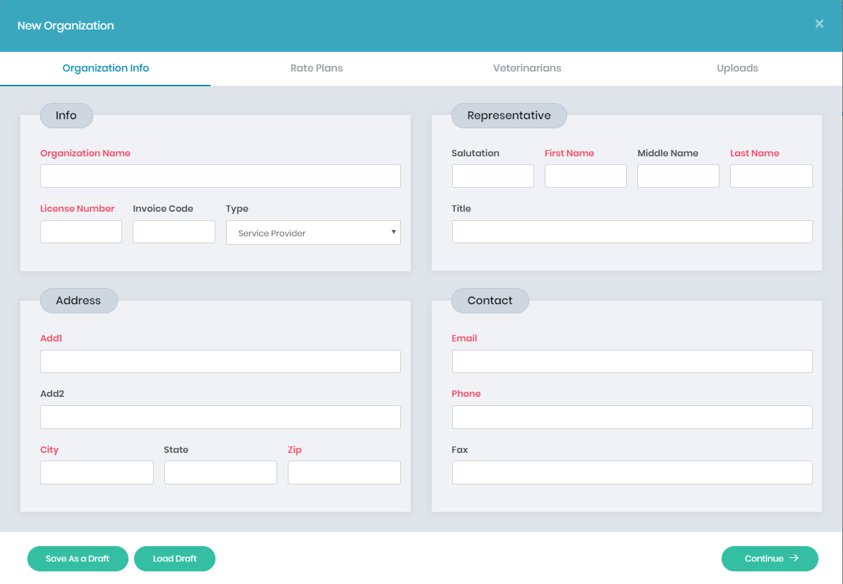
6. First tab is about organization info. Fill the from Properly and click continue
7. Second tab is about the rate plan choose the rate plan and click Continue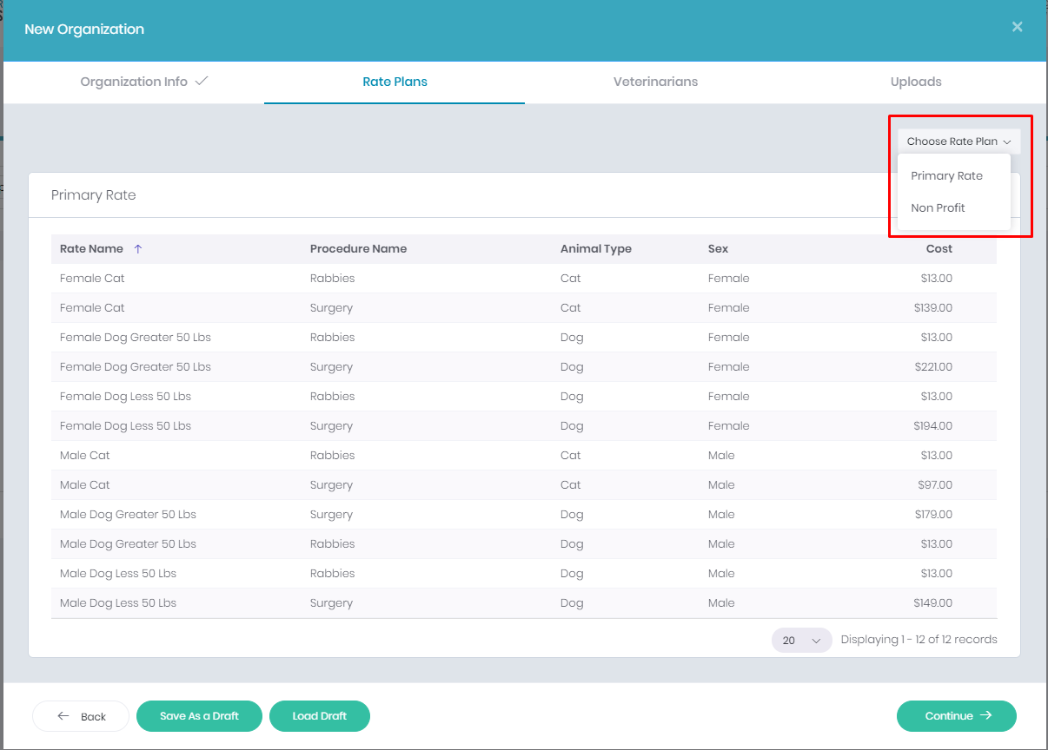
8. Third tab is to add the veterinarians, Add the veterinarians and click continue
9. Fourth Tab is for Support Document upload it and click save
10. After saving the Organization You will see view like following 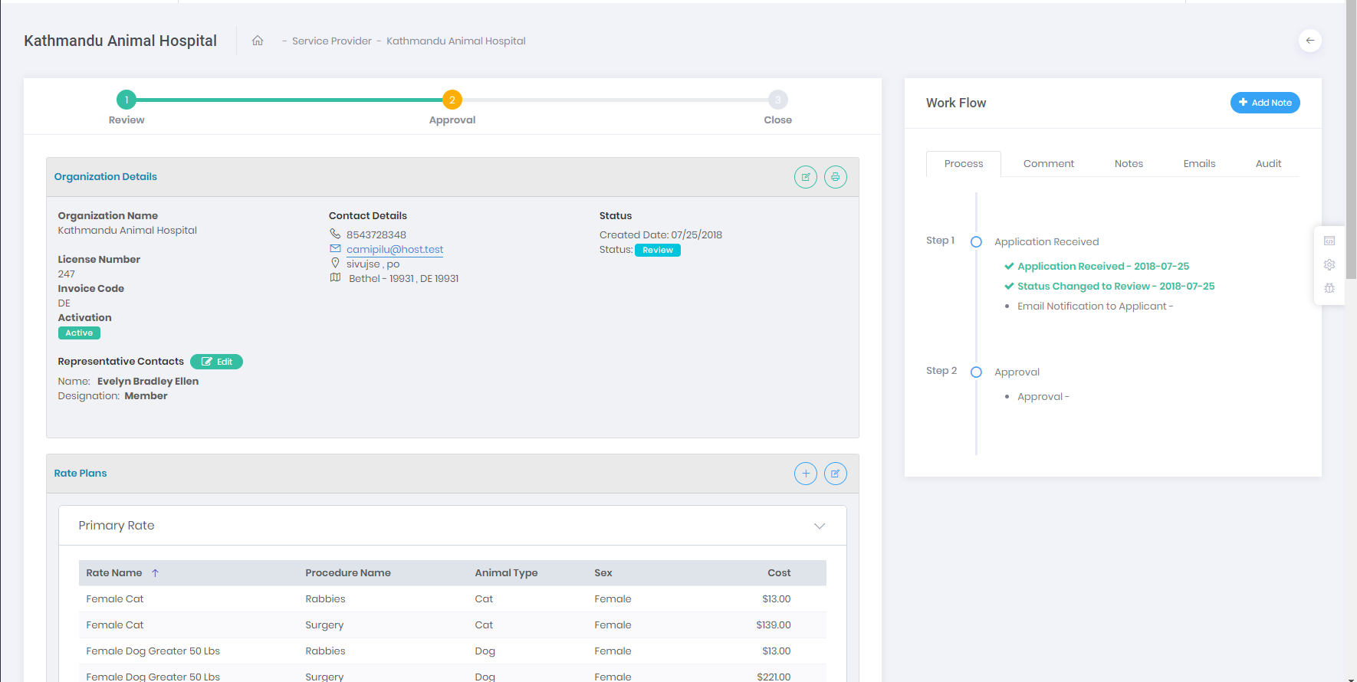

## How to Approve/Disapprove Providers?

1. Click on Provider on side menu
2. The list will by default show the pending and Review applications
3. Click on the view icon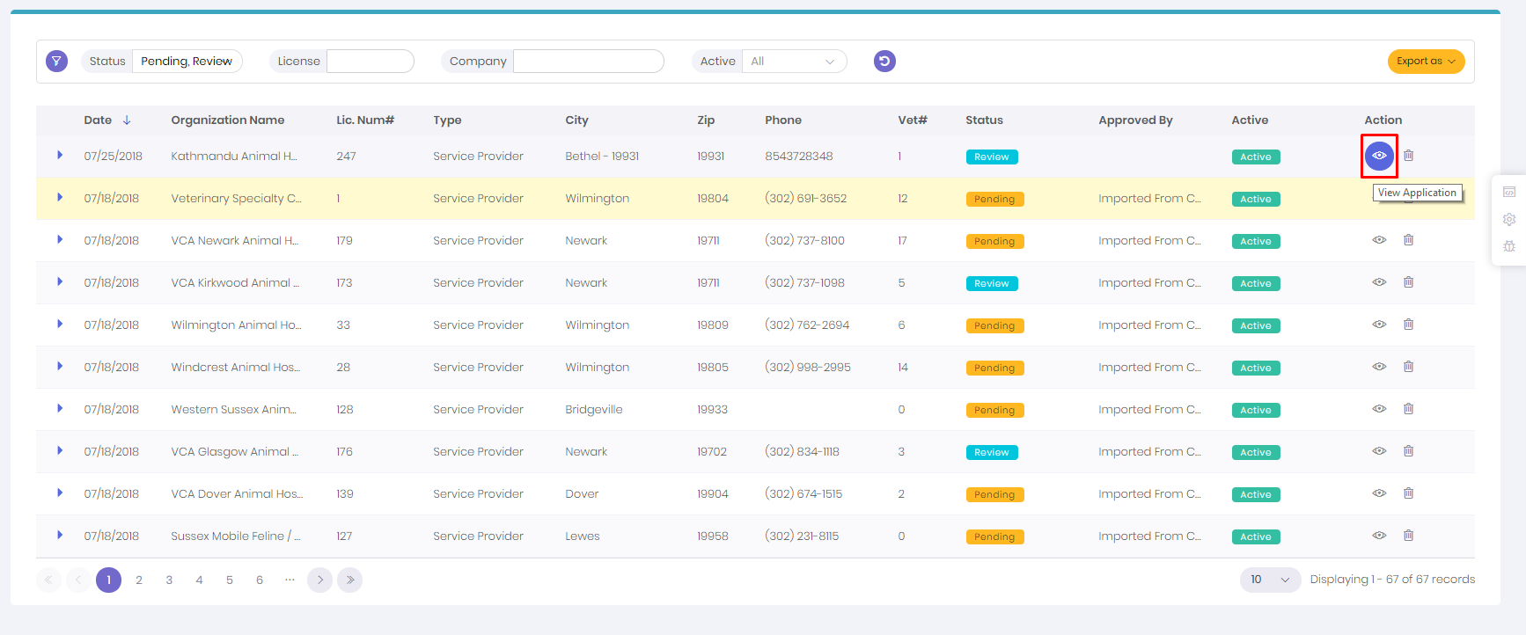
4. If all details are correct scroll down, On bottom there is Approve and disapprove button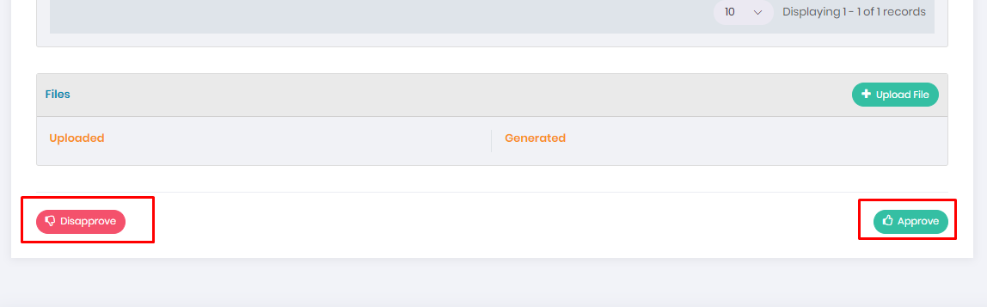
5. For approval click the approve button of right side
6. A confirmation dialog will open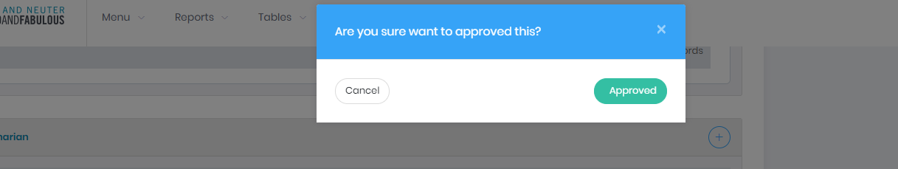
7. Click the approved button. It’ll take a little time for approval
8. For Disapprove Click the red disapprove button on left side
9. A confirmation dialog will open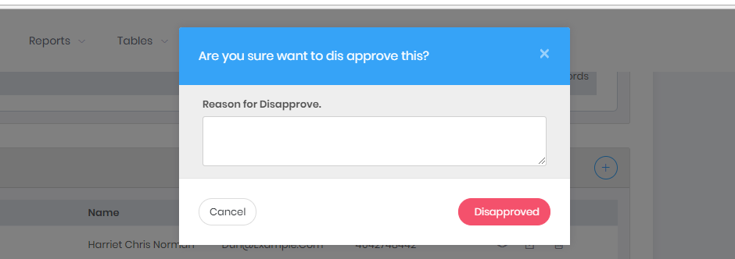
10. Enter the reason and click disapproved. It’ll take little time
11. After Approve, disapprove a letter will be generated Respectively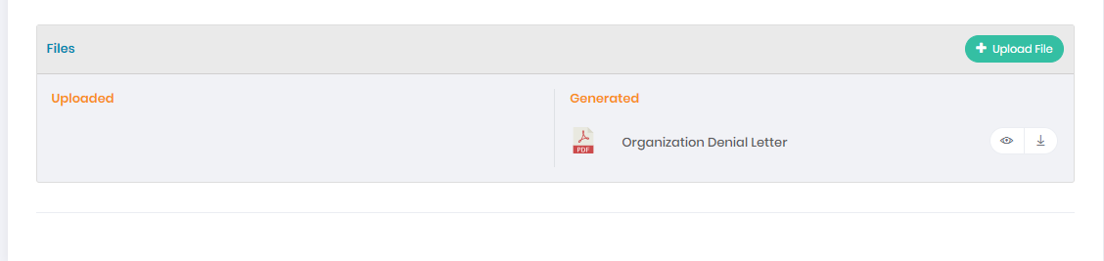

## How To add new Veterinarian

1. Click on Provider on side menu
2. The list will by default show the pending and Review applications
3. View the organization in which You want to add Veterinarian
4. Go to veterinarian section 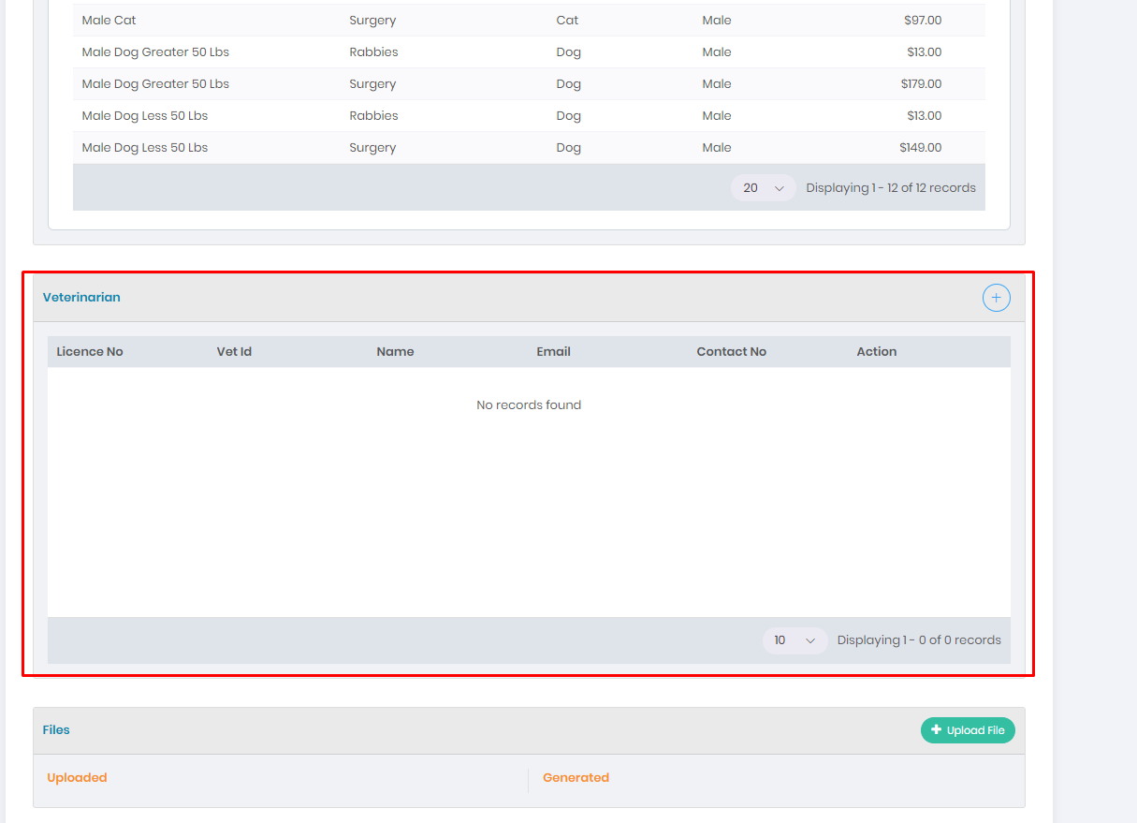
5. Click on the add icon on the right side 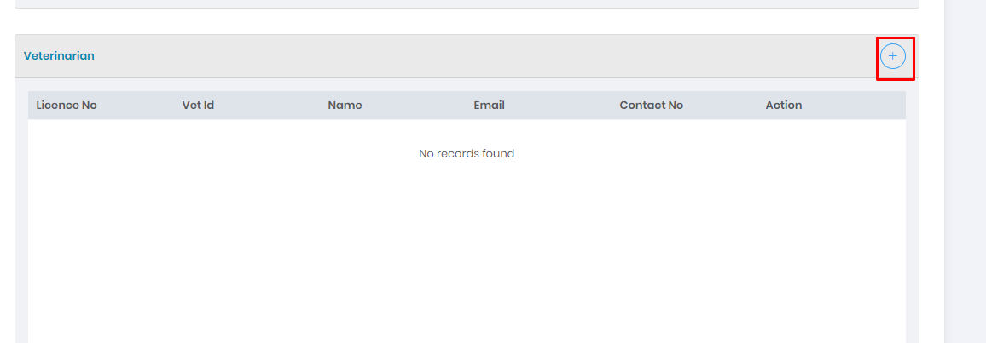
6. A dialog will open 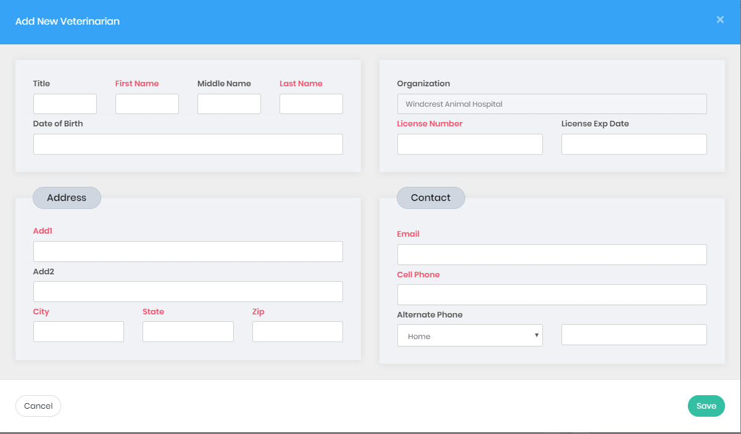
7. Fill The form Properly and click save
8. A list of vetenerian will show up

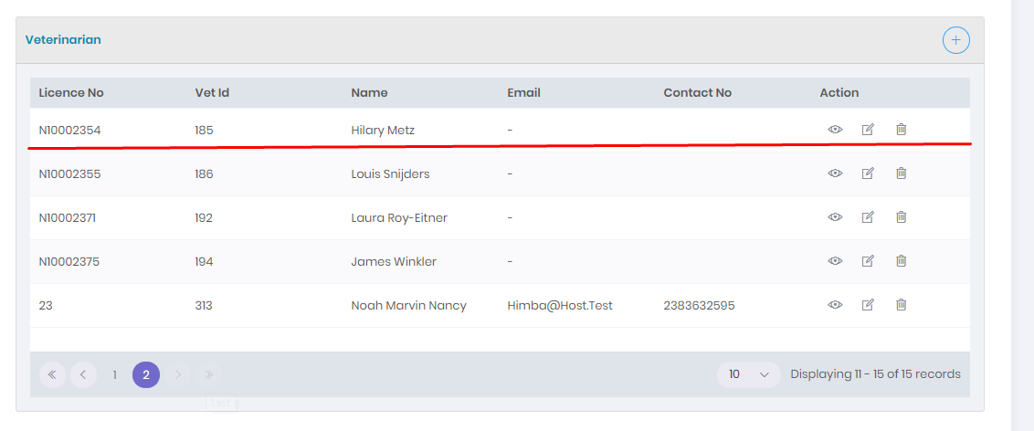

## How to edit Organization Details?

1. View the Organization You want to edit
2. On the Organization Details Panel there is edit button 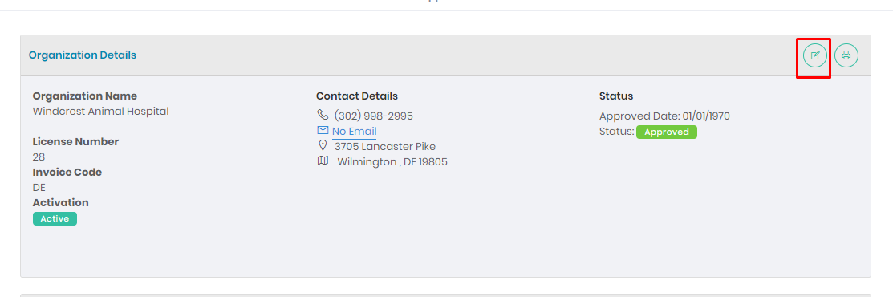
3. Click the edit icon , A dialog will show 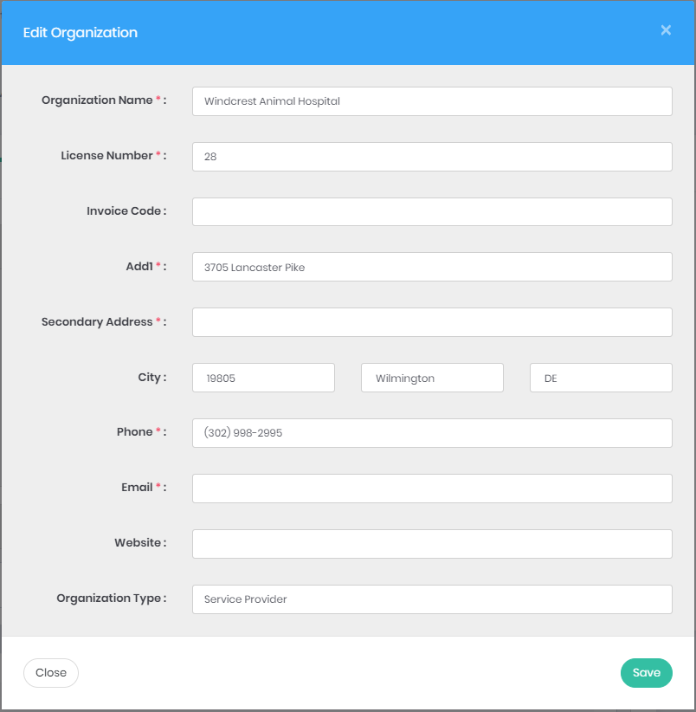
4. Change The details you want to and click save
5. A Success Message will shownup and View Will update 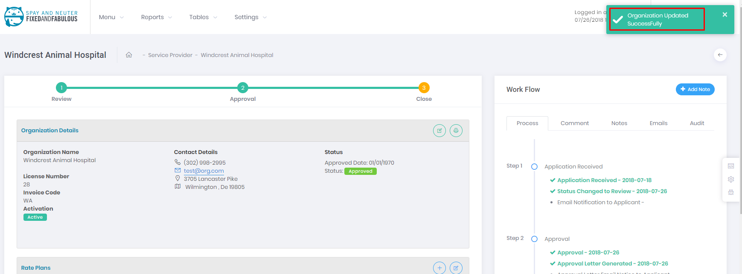

# Invoice

## Creating New Invoice

1. Click on the Invoice in side menu
2. Click the add invoice 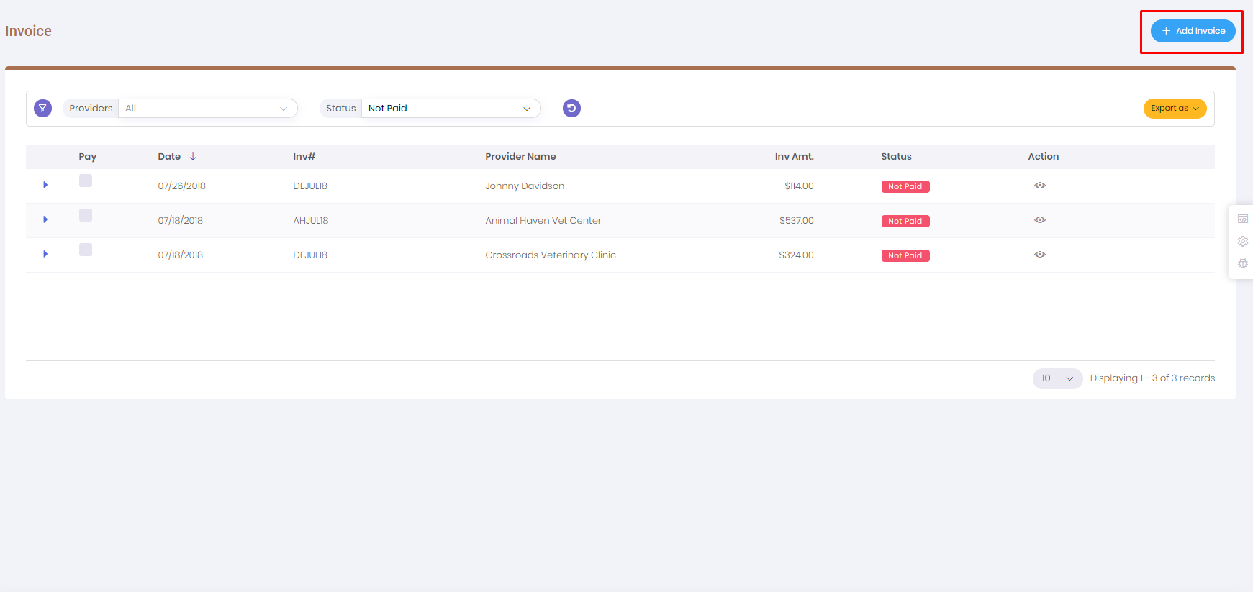
3. Choose The service Provider 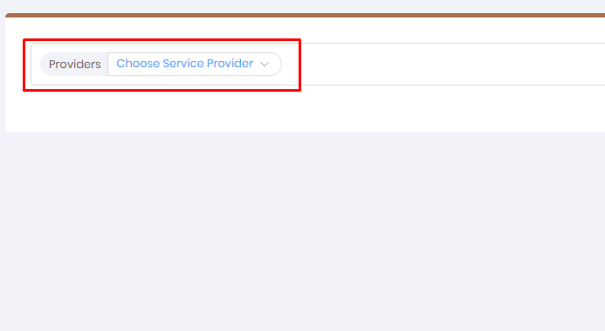
4. A From Will show up 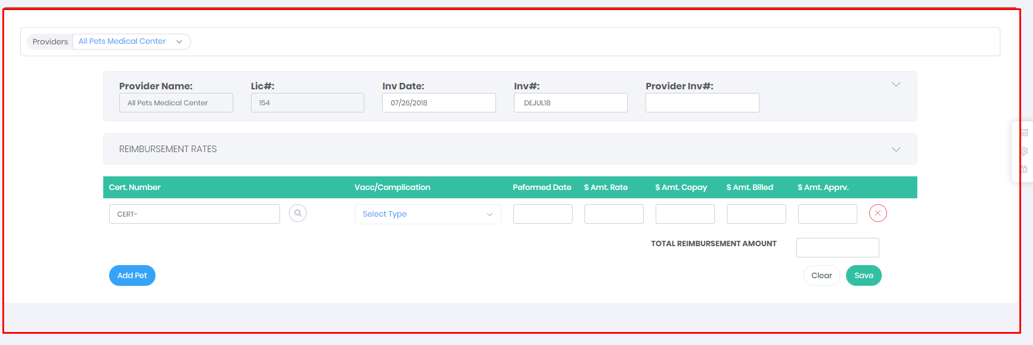
5. On entering the Certificate number The Pet details will show up 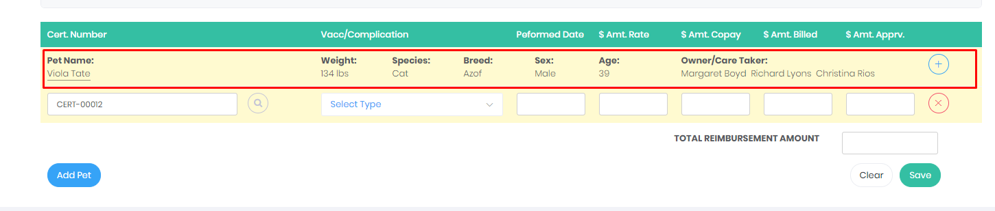
6. To add new Pet Click on the Add pet Button 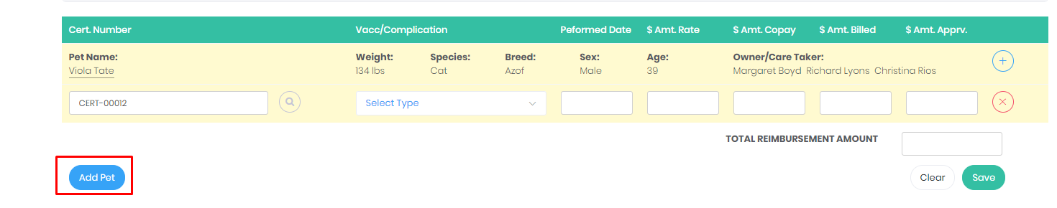
7. Before pressing save make sure you have choose the Treatment and enter amount properly 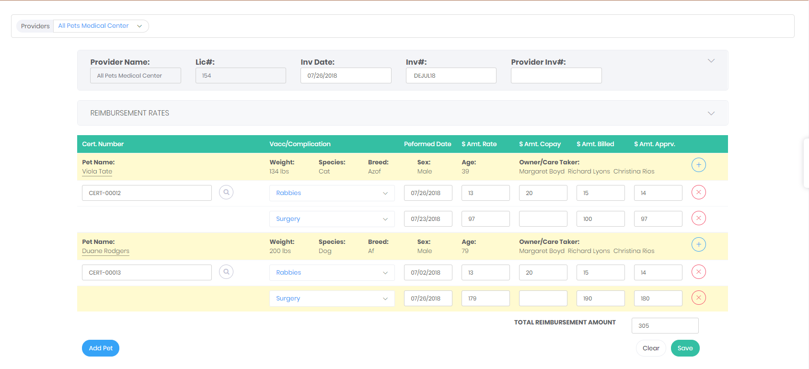
8. Click save to save invoice 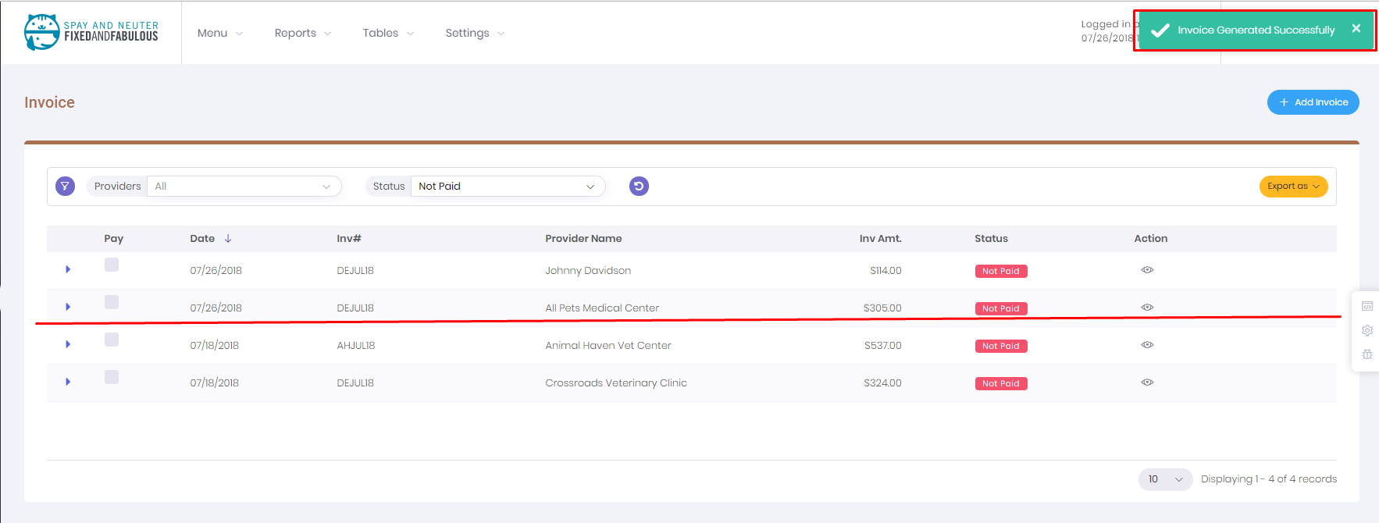

## How to edit invoice

1. Click on the view icon (Note: Once Paid Invoice can’t be editted)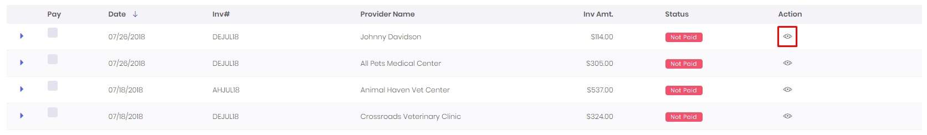
2. A dialog will open, on the bottom right click on the edit button 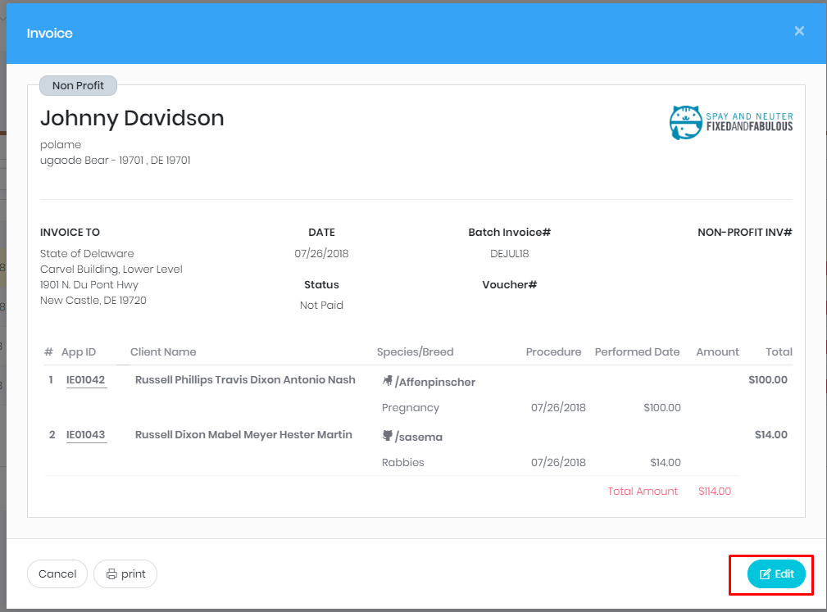
3. The Edit Form will open 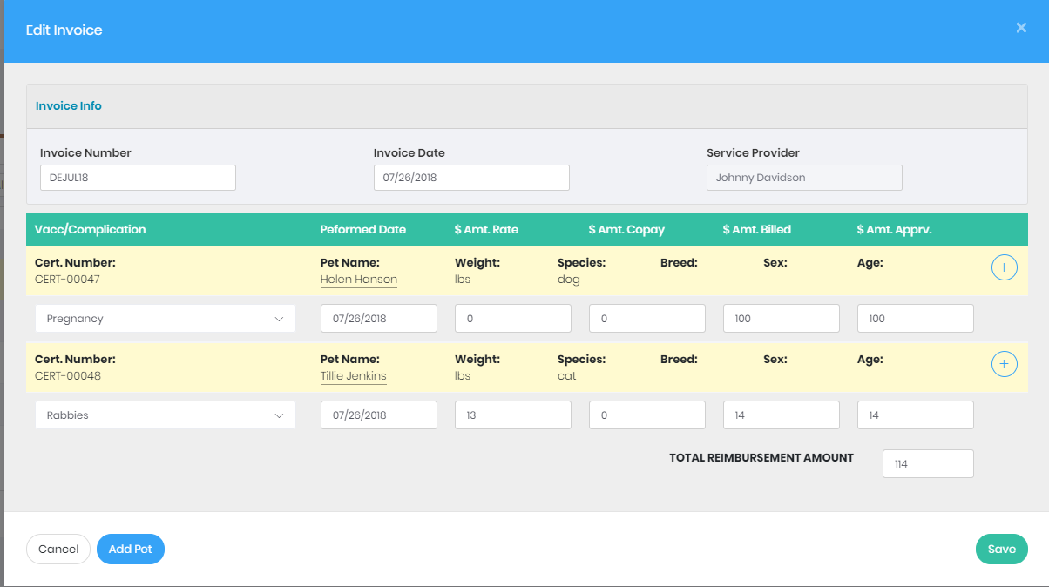
4. Edit the field or add new pet
5. Click the save button, previous modal will open , success meaage will shown 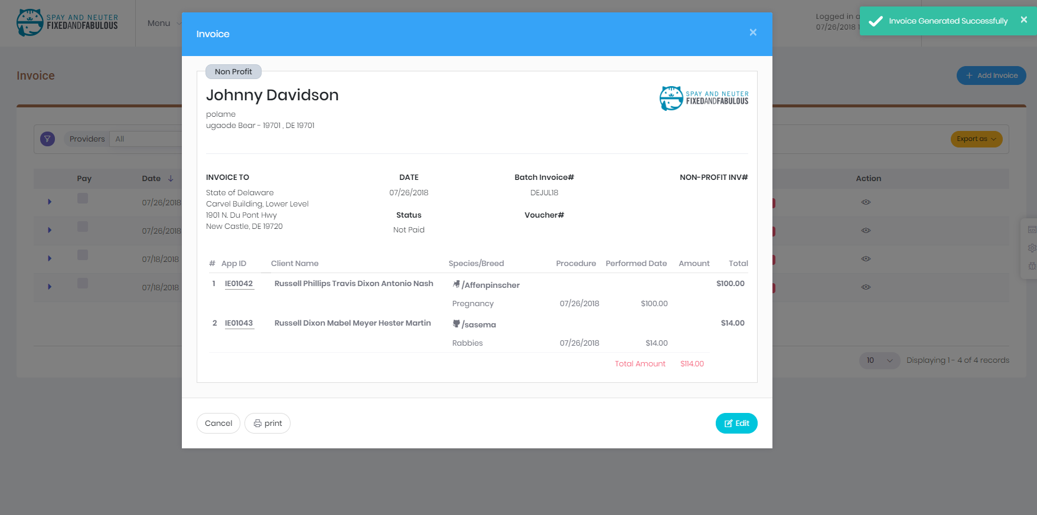

## How to make payment

1. Go to the Invoice
2. Click the pay checkbox 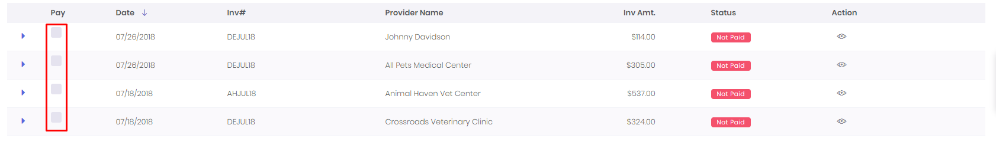
3. Upon selecting the checkbox Payment Button will appear and only the data of corresponding Provider will show 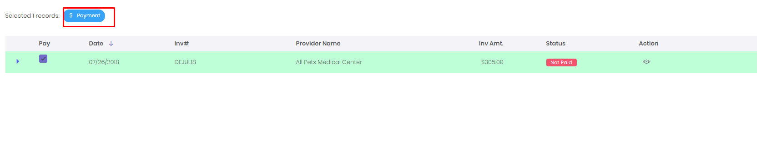
4. Click the payment button , a dialog will show 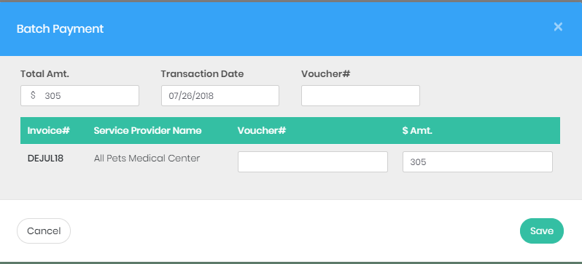
5. Fill the data and click save. 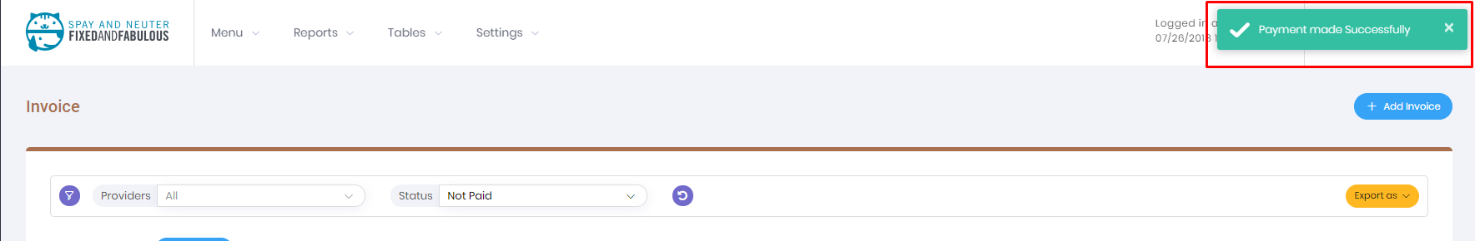

# Post Mail

Post mail is the list of the Applicant’s whose application are either Approved or Denial. It has two view

1. Generate view:- list of all applicants
2. File view: list of all generated file

## How to Generate the file

1. Click on Postal mail
2. A List of Applicants will show 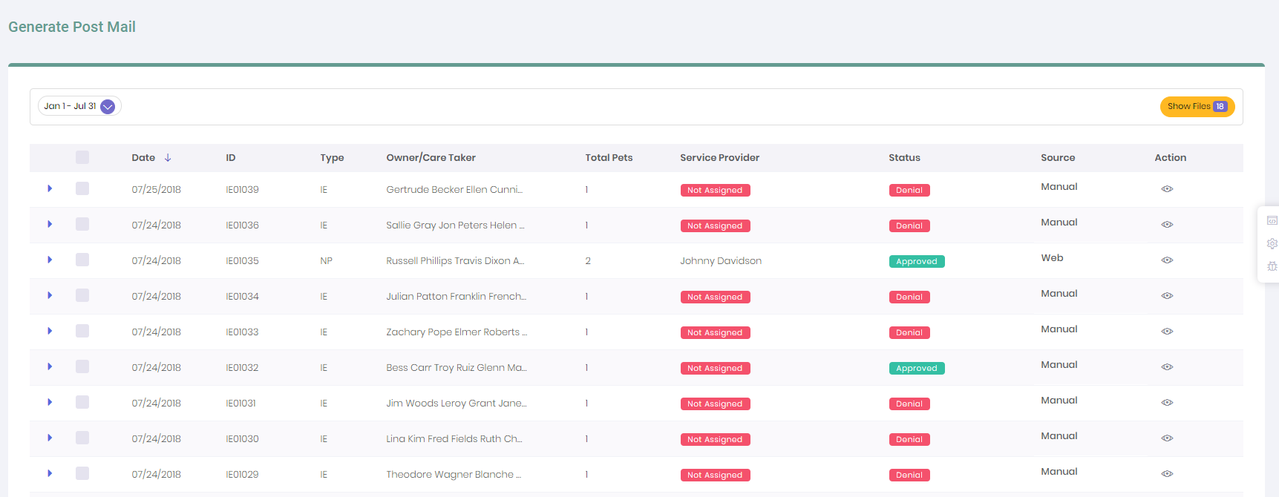
3. Select the application for which you want to generate Files
4. Once you check the box a generate button will show 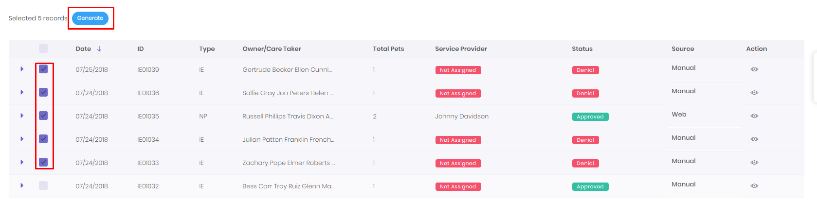
5. Click the generate button. It’ll take some time to generate file. Once generated the view will change in to file view. 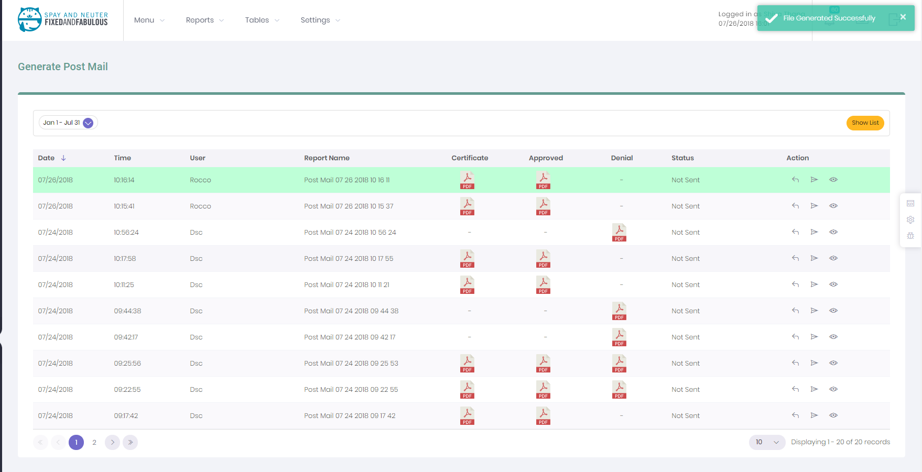

## How to send report

1. Go to Postal mail
2. Click on the show files 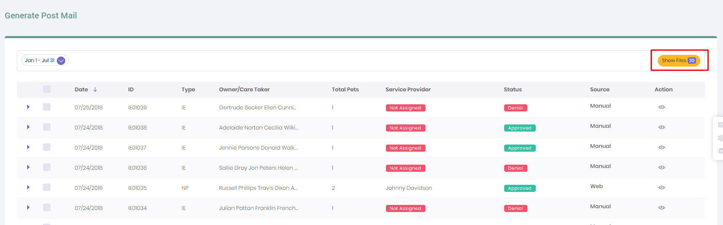
3. A list of generated report will show
4. Click on the sent report icon 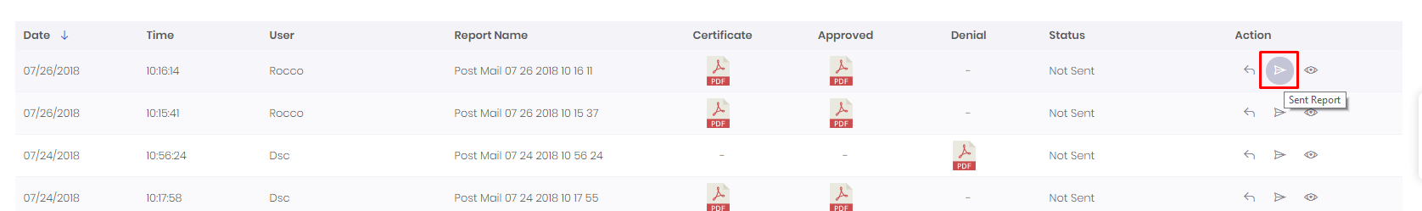
5. A dialog will open for the tracking process 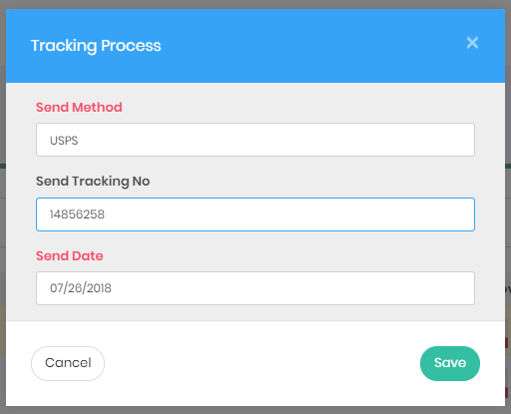
6. Click Save.
7. The send report will display as grayscale 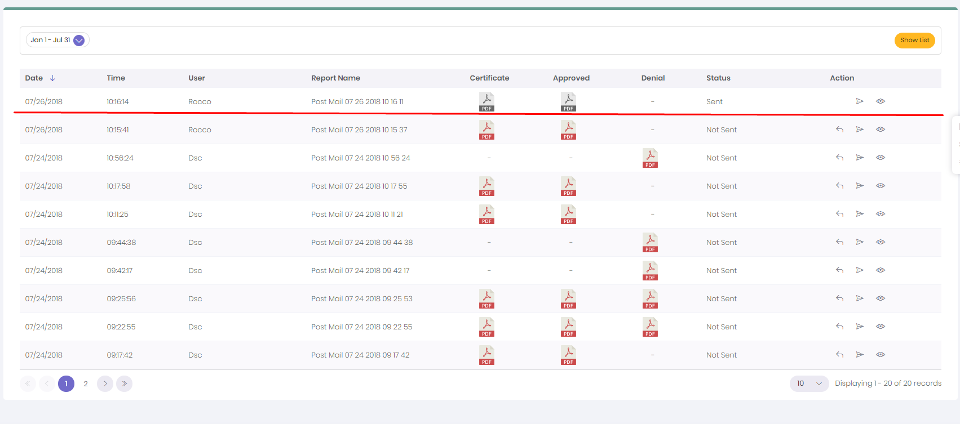

## How to undo the generated Mail

1. Go to post mail
2. Click the show files
3. Click on the undo icon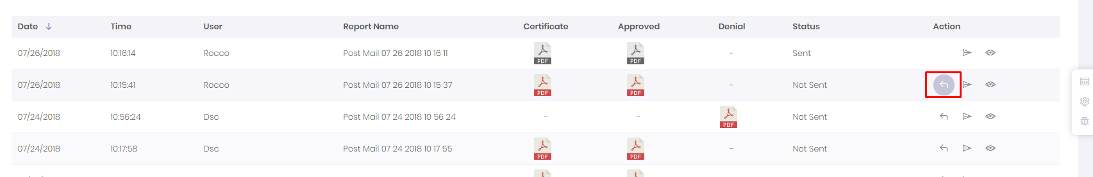
4. The file will be on change to previous state